Basic Vocabulary of Mesqan (1)*

Abstract
This paper describes the basic vocabulary in Mesqan language spoken in Ethiopia, and its phonetic and phonological features.

1 Introduction
The author made investigation on Mesqan (Mäsqan) language at Butajira, Gurage Zone, Southern Nations, Nationalities and Peoples' Region of Federal Democratic Republic of Ethiopia on August 7-17, 2010.

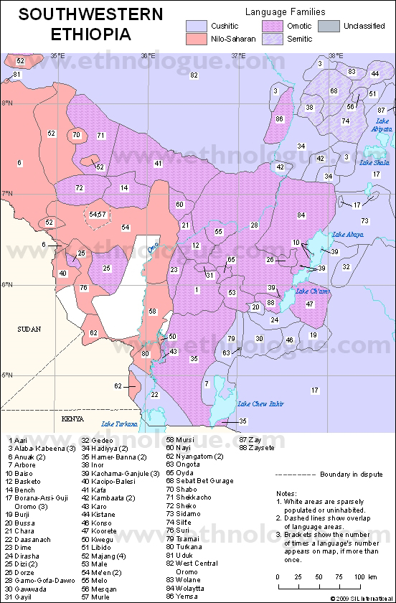
Figure 1: Map of the southwestern Ethiopia , based on Gordon (2005)
(Mesqan language is used in the area surrounded by ○)

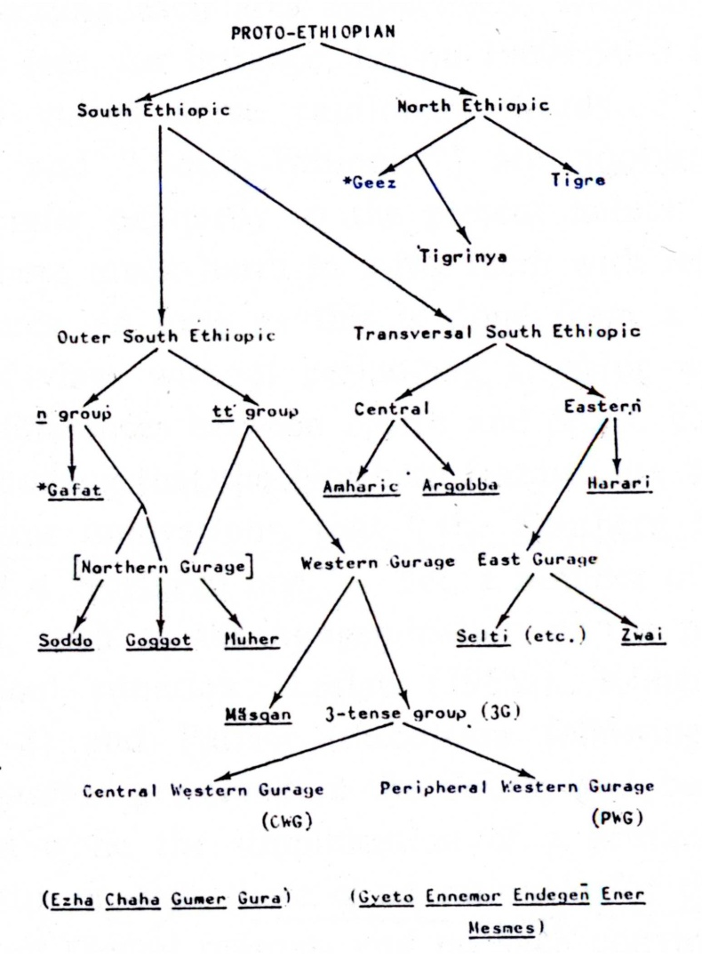
Figure 2: Family tree on the Ethio-Semitic languages based on Hetzron (1977: 17)
(Mesqan is surrounded by ○)

According to the research assistant of this research, Mesqan language is neither written nor taught at school.

2 Previous Works
Leslau (1979) shows the following inventory of phonemes, both vowels (Figure 3) and consonants (Table 1). Note that infrequent sounds are shown by parenthesis.

i | ə / (ə̃) | u
e | ä | o
 | a / (ã)
Figure 3: Vowel inventory (Leslau 1979: xxi)

Table 1: Consonant inventory (Leslau 1979: xxii-xxiv)
 | Labial |  | Labio-  dental | Dental or Alveolar |  | Postalveolar or Palatal |  | Prepalatal |  | Velar |  | Glottal
Plosive |  | b |  | t | d |  |  |  |  | k | g | (ʼ)
Nasal |  | m |  |  | n |  | ň
Liquid |  |  |  |  | r  l
Fricative | f |  |  | s | z | š | ž |  |  | x |  | h
Approximant |  | w |  |  |  |  |  |  | y
Affiricative |  |  |  |  |  | č | ǧ
Labialized |  | b^{w} | f^{w} |  |  |  |  |  |  | k^{w}  x^{w} | g^{w}  m^{w}
Palatalized |  |  |  |  |  |  |  |  |  | kʹ  xʹ | gʹ
Laringealized |  |  |  | ṭ |  | č̣ |  |  |  | q  q^{w}  qʹ

3 Research Method
3.1 Reearch Assistant
The research data was collected on August 7-17 at Butajira, Ethiopia. The research assistant was Mr. AH. who was born at Butajira and now lives there. Mr. AH is male, fifty-two years old at the time of the research. He stayed Butajira during his critical period. He speaks Mesqan, Amharic and English. He writes in Amharic and English.

3.2 Recording
The recording was done inside a sound room, by Edirol R-09HR (Roland) with a dynamic microphone SM58SE (Shure). The microphone was mounted by a window screen A58WQ-BLK (Shure). The data was saved in wave-format, its samlping rate was 44,100Hz, quantified by 16 bits, monaural recording.
In the research of vocabulary, the assistant was showen each word in English and Amharic in order to confirm whether he understood the accurate meaning. Then he made utterance in Mesqan for the word three times. The author used the vocabulary list published by Research Institute for Languages and Cultures of Asia and Africa (1979), in which the data was collected till No. 0346 (to simmer) this time. Leslau (1979) shows the following inventory of phonemes, both vowels (Figure 3) and consonants (Table 1). Note that infrequent sounds are shown by parenthesis.
Leslau (1979) shows the following inventory of phonemes, both vowels (Figure 3) and consonants (Table 1). Note that infrequent sounds are shown by parenthesis.
Leslau (1979) shows the following inventory of phonemes, both vowels (Figure 3) and consonants (Table 1). Note that infrequent sounds are shown by parenthesis.
Leslau (1979) shows the following inventory of phonemes, both vowels (Figure 3) and consonants (Table 1). Note that infrequent sounds are shown by parenthesis.
Leslau (1979) shows the following inventory of phonemes, both vowels (Figure 3) and consonants (Table 1). Note that infrequent sounds are shown by parenthesis.
Leslau (1979) shows the following inventory of phonemes, both vowels (Figure 3) and consonants (Table 1). Note that infrequent sounds are shown by parenthesis.
Leslau (1979) shows the following inventory of phonemes, both vowels (Figure 3) and consonants (Table 1). Note that infrequent sounds are shown by parenthesis.
Leslau (1979) shows the following inventory of phonemes, both vowels (Figure 3) and consonants (Table 1). Note that infrequent sounds are shown by parenthesis.
Leslau (1979) shows the following inventory of phonemes, both vowels (Figure 3) and consonants (Table 1). Note that infrequent sounds are shown by parenthesis. Leslau (1979) shows the following inventory of phonemes, both vowels (Figure 3) and consonants (Table 1). Note that infrequent sounds are shown by parenthesis.
Leslau (1979) shows the following inventory of phonemes, both vowels (Figure 3) and consonants (Table 1). Note that infrequent sounds are shown by parenthesis.
Leslau (1979) shows the following inventory of phonemes, both vowels (Figure 3) and consonants (Table 1). Note that infrequent sounds are shown by parenthesis.
Leslau (1979) shows the following inventory of phonemes, both vowels (Figure 3) and consonants (Table 1). Note that infrequent sounds are shown by parenthesis.
Leslau (1979) shows the following inventory of phonemes, both vowels (Figure 3) and consonants (Table 1). Note that infrequent sounds are shown by parenthesis.
Leslau (1979) shows the following inventory of phonemes, both vowels (Figure 3) and consonants (Table 1). Note that infrequent sounds are shown by parenthesis.
Leslau (1979) shows the following inventory of phonemes, both vowels (Figure 3) and consonants (Table 1). Note that infrequent sounds are shown by parenthesis.
Leslau (1979) shows the following inventory of phonemes, both vowels (Figure 3) and consonants (Table 1). Note that infrequent sounds are shown by parenthesis.
Leslau (1979) shows the following inventory of phonemes, both vowels (Figure 3) and consonants (Table 1). Note that infrequent sounds are shown by parenthesis.
Leslau (1979) shows the following inventory of phonemes, both vowels (Figure 3) and consonants (Table 1). Note that infrequent sounds are shown by parenthesis.
Leslau (1979) shows the following inventory of phonemes, both vowels (Figure 3) and consonants (Table 1). Note that infrequent sounds are shown by parenthesis.

4 Basic Vocabulary

Table 2：Basic Vocabulary in Mesqan
No. | Meaning | Form
0001 | head | [ɡunːɐn] / gunnan (L: 784)
0002 | hair | [ɡunːɐn] / gunnan (L: 784)
0003 | forehead | [ɡəmbaɾ] / fənč̣ä (L: 779)
0004 | eyebrows | [k’ərəb] / qərrəb (L: 806)
0005 | eye | [eːn] / en (L: 757)
0006 | tear | [imba] / əmba (L: 756)

5 Conclusion
This report shows the basic vocabulary in Mesqan by phonetic form, and makes clear the phonetic and phonological features of the segments.

References
Research Institute for Languages and Cultures of Asia and Africa (ed.) (1979) Ajia-Afurika Gengochosahyo (A Survey Sheet for Asia and African Languages). Tokyo: Tokyo University of Foreign Studies.(in Japanese)
Crass, Joachim (2005) Hadiyya. In: Siegbert Uhlig (ed.) Encyclopaedia aethiopica, vol. 2: 960-961. Wiesbaden: Harrassowitz.
Gordon, Raymond G. (2005) Southwestern Ethiopia. In: Raymond G. Gordon (ed.) Ethnologue: Languages of the world. Fifteenth edition. Dallas, Texas: SIL International.
Hetzron, Robert (1977) The Gunnän-Gurage. Napoli: Istituto Orientale di Napoli.
Hetzron, Robert and Berhanu Chamora (2000) Inor. Münich: Lincom Europa.
Hogan, John T. (1976) An analysis of the temporal features of ejective consonants. Phonetica 33: 275-284.
Hudson, Grover (1976) Highland East Cushitic. In: M. Lionel Bender (ed.) The non-Semitic languages of Ethiopia, 232-277. East Lansing: Michigan State University.
Hudson, Grover (1989) Highland East Cushitic dictionary. Hamburg: Helmut Buske Verlag.
Jouo, Hakutaro (2008) Ippan Onseigaku Kougi (Course in General Phonetics). Tokyo: Bensei Publishing. (in Japanese)
Korhonen, Elsa, Mirja Saksa and Ronald James Sim (1986a) A dialect study of Kambaata-Hadiyya (Ethiopia). Afrikanistische Arbeitspapiere 5: 5-41.
Korhonen, Elsa, Mirja Saksa and Ronald James Sim (1986b) A dialect study of Kambaata-Hadiyya (Ethiopia) Part 2: Appendices. Afrikanistische Arbeitspapiere 6: 71-121.
Leslau, Wolf (1979) Etymological dictionary of Gurage (Ethiopic): Individual dictionaries. vol.1. Wiesbaden: Otto Harrassowitz.
Stinson, D. Lloyd (1976) Hadiyya. In: M. Lionel Bender et al. (eds.) Language in Ethiopia, 148-154. London: Oxford University Press.
Tsuge, Yoichi (1992) Hadiyya. In: Kamei, Takashi et al. (eds.) Gengogaku Daijiten: Sekai Gengo hen (Encyclopedia of Linguistics: World Languages), vol. 3: 181-182. Tokyo: Sanseido. (in Japanese)

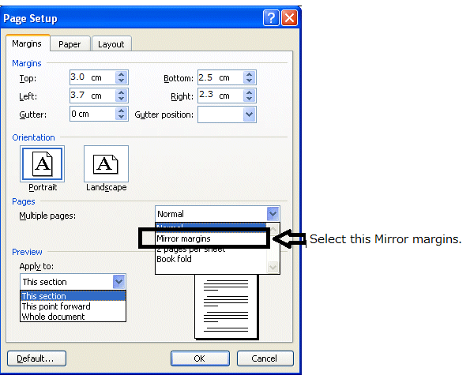

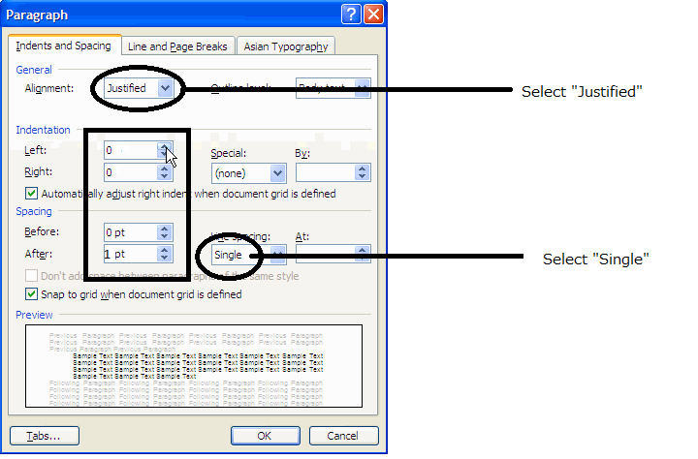

* This research was supported by the Grant-in-Aid for Scientific Research ‘Comprehensive Study on the Static and Dynamic Aspects of the Language Change in Ethiopia’ (Grant Number: 22401046). The Abbreviation in this article: 2 = Second person, 3 = Third person, sg. = Singular, pl. = Plural, m. = Masculine, f. = Female.

